- Creating a Database to File job

Estimated time
01:30

What this exercise is about
This exercise covers the process of creating connection, creating table definition by importing metadata from database, creating parameter set, creating a DataStage parallel job which reads from a database table and write to a flat file.

What you should be able to do
At the end of this exercise, you should be able to:
- Create database connection
- Create table definition by importing metadata from database table
- Design a DataStage parallel job which reads from a database table and write to a flat file
- Define and use job parameters in the job
- Define and use a parameter set in the job

Task: Create a database connection
- Go to Connections tab and click on Create+ link.
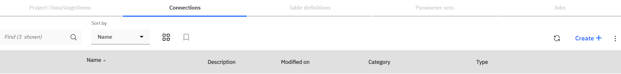
- New Connection window will appear. Enter connection name as Connection_JDBC.
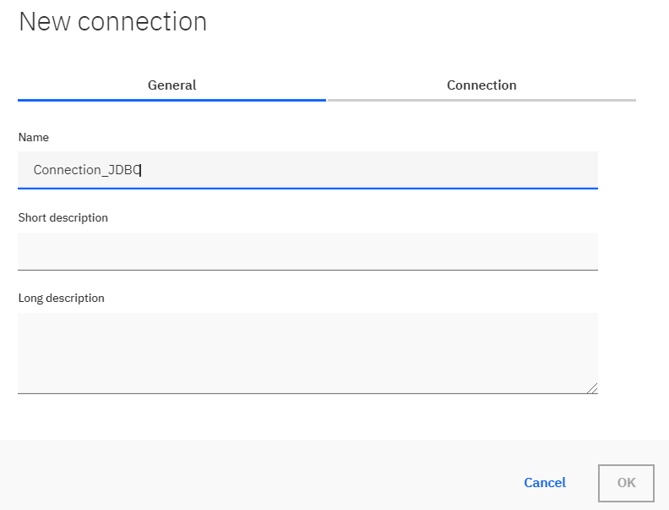

- Go to Connection tab and select JDBC option from Connector type drop down. Now enter the values as below and click on OK.
URL : jdbc:db2://10.191.195.39:32732/BLUDB
User name : dev3
Password : <password will be provided later>

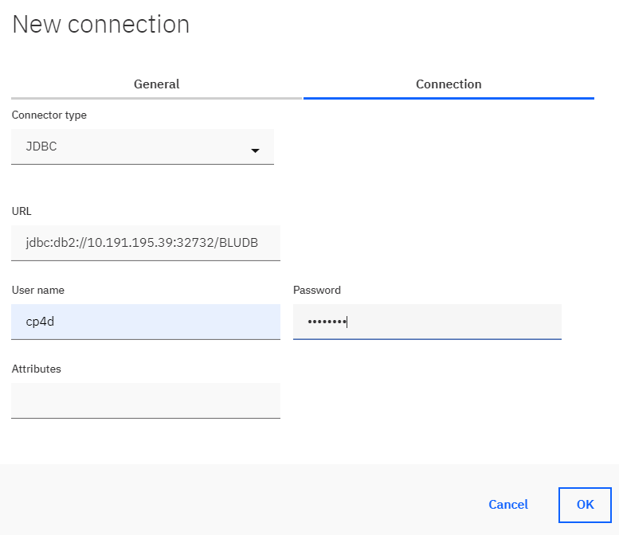
- In the next window click on Save button. Now you can see your connection is created and listed.

Task: Create a table definition
- Go to Table definitions tab and click on the 3 vertical dots to the right of the screen. It will bring a drop down. Click on Import.
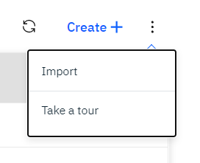

- Import table definition window will appear. Click on Connection_JDBC and click on Next button.
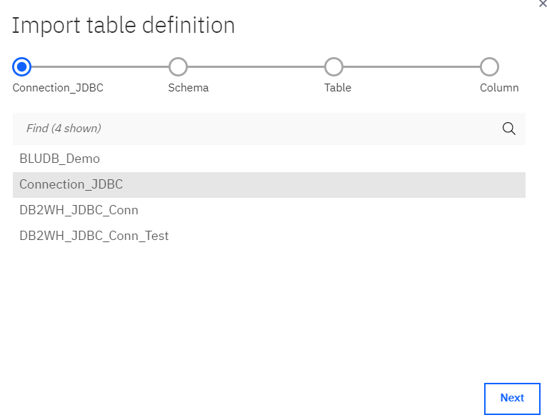
- Now select CP4D schema and click on Next.
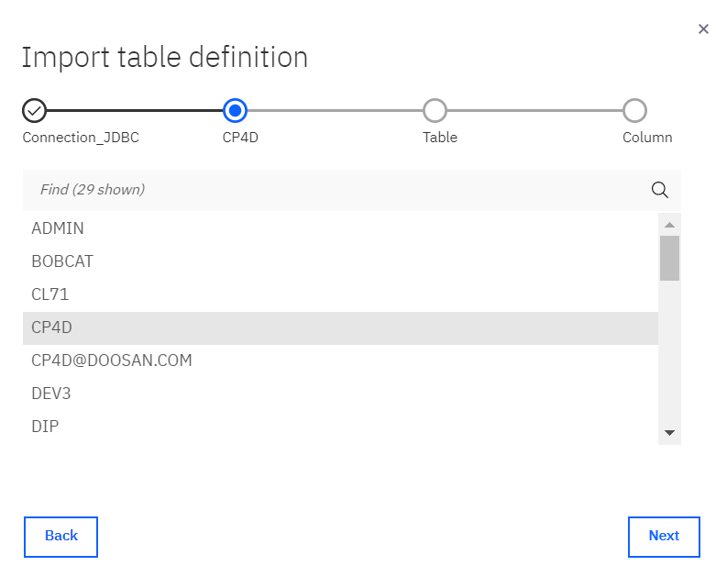
- Now select BOOKS table and click on Next.
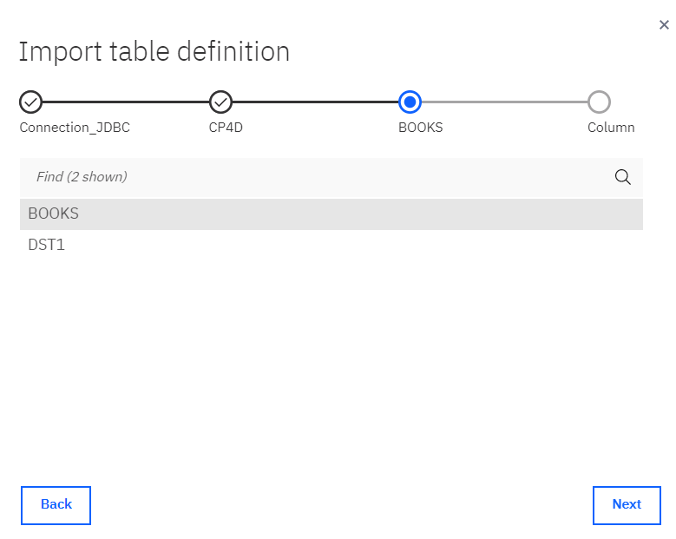
- By default, all columns are selected. Click on Finish.
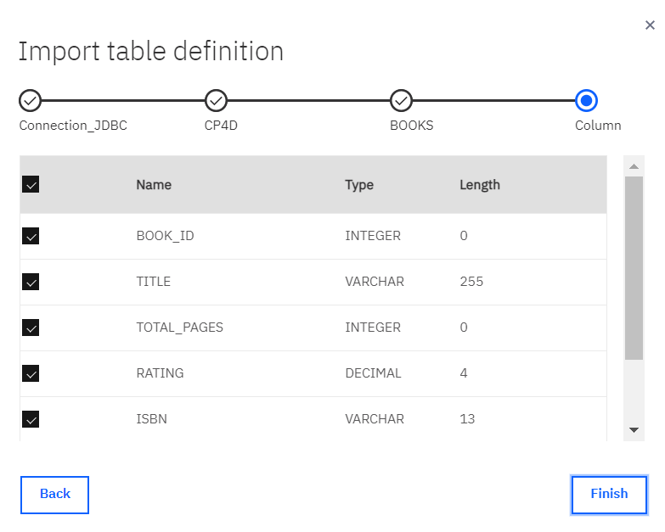
- Now Save table definition window will appear. Click on Save.
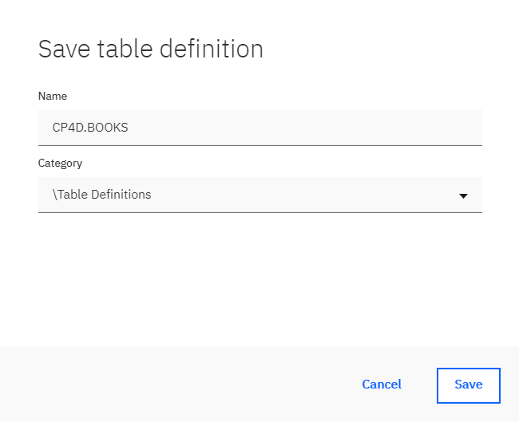

Task: Create a parameter set
- Go to Parameter sets tab and click on Create + link. New parameter set window will appear
- In the Genaral tab of New parameter set window, enter ps_JDBC_Conn as the Parameter set name.
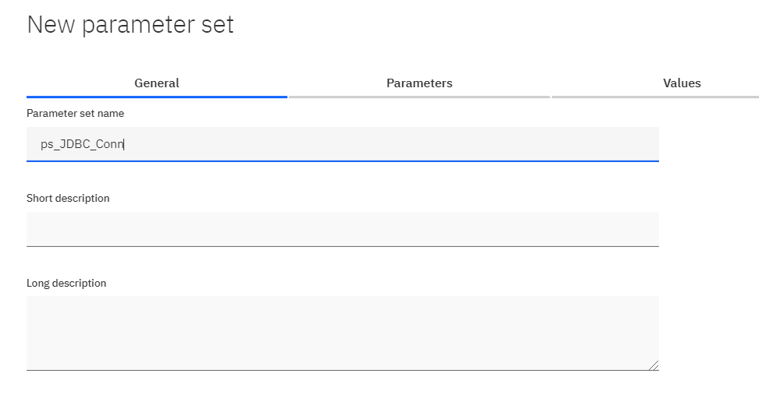
- Go to Parameters tab, click on Add+ link to add parameters. In the Add parameter window add/select the following values and click on OK.
Type : String
Parameter name : p_JDBC_URL
Default value : jdbc:db2://10.191.195.39:32732/BLUDB
Prompt : Enter JDBC URL
- Add second parameter as follows:
Type : String
Parameter name : p_Username
Default value : dev3
Prompt : Enter the username

- Add the third and last parameter as follows:
Type : Encrypted
Parameter name : p_Password
Default value : < password will be provided later >
Prompt : Enter the password
- Now New parameter set window will look like below. Click on OK.
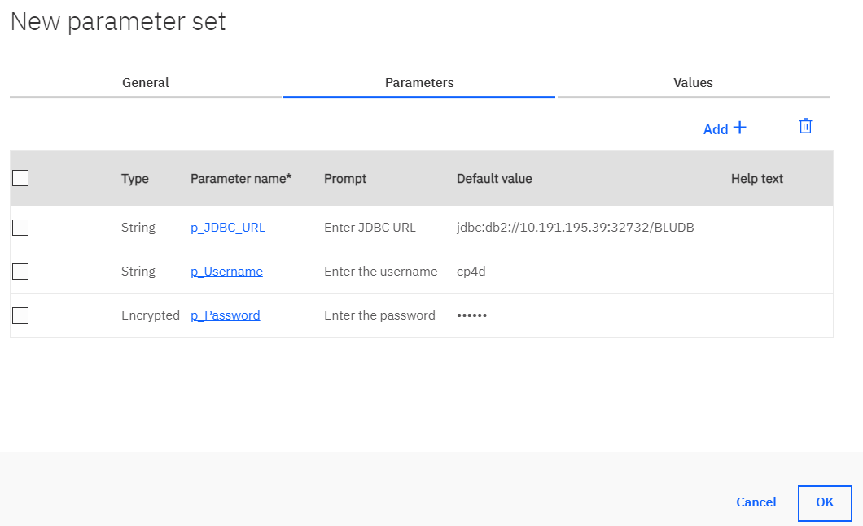
- In the Save parameter set window, click on Save button. Now you can see the parameter set got created and listed.
Task: Create JDBC to File parallel job
- Open your project and click on Jobs tab after the project is opened.

- While in Jobs tab click on Create + button. A drop will appear, now click on Parallel job.
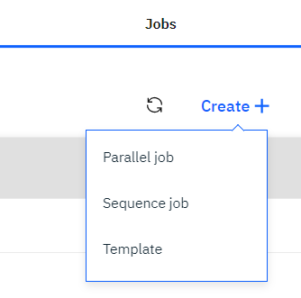
- Now you can see the below screen
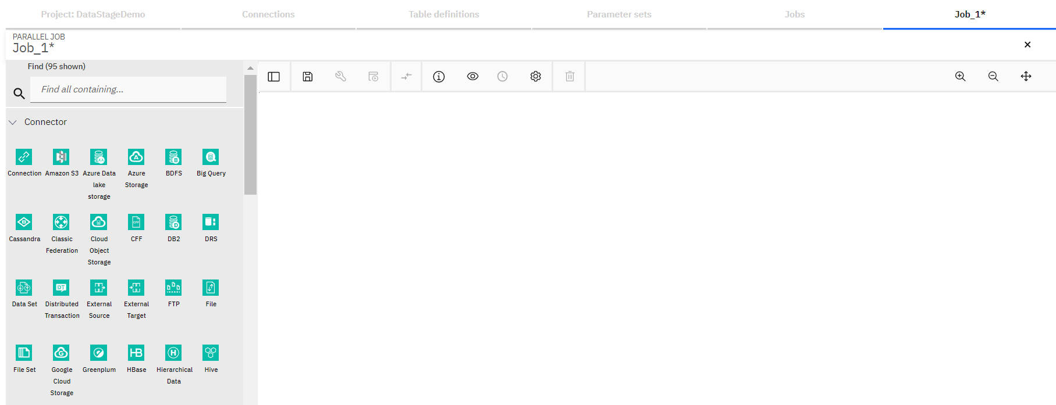
- Now type JDBC in the Find search box and you can see JDBC connector appears in the palette

- Drag the JDBC connector onto the canvas

- You can see Table definition asset browser window appears. Select BLUEDB\CP4D.BOOKS and click on Next.
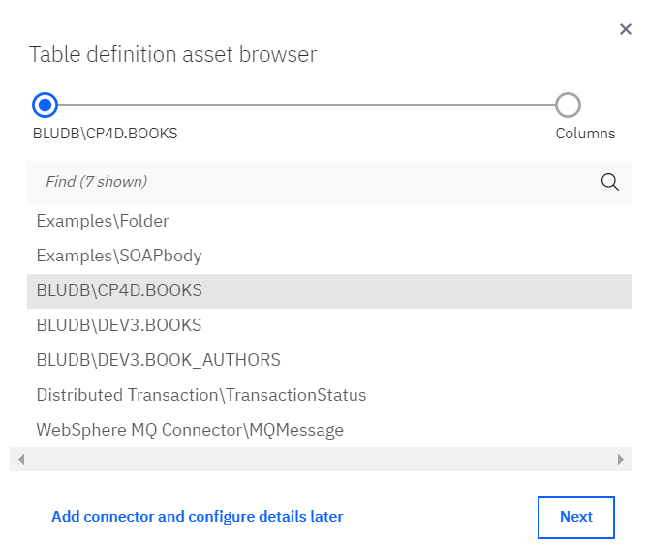
- In the next screen, by default, all columns are selected. Click on Add to job button.
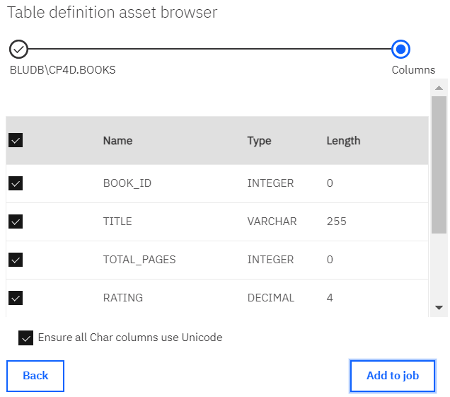
- Now search for File in the Find box and File connector will appear. Drag the File connector on to canvas and place it to the right of JDBC connector. Select BLUEDB\CP4D.BOOKS in the Table definition asset browser. Link the stages if not linked automatically.

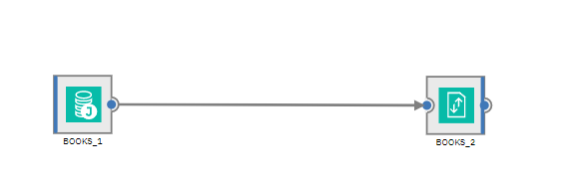

- Save the job by clicking on the save icon. Name it as Job_JDBC_File.
- Click on the properties icon.

- In the Parameters tab of Job properties window, click on Add+ link.
- In the Add parameter window, add the following values and click on OK.
Type : String
Parameter name : p_FileName
Default value : BOOKS<Your First Name><Initial of your Last Name>.txt
Prompt : Enter the file name
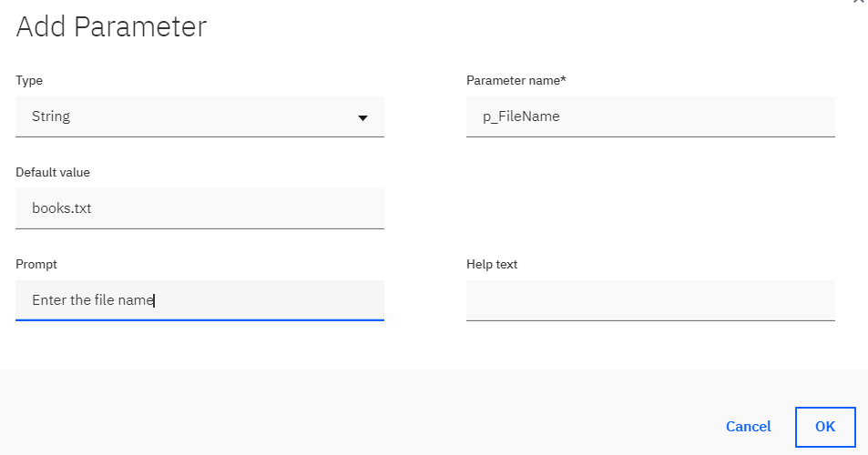

- Click on Add+ again. In the Add Parameter window, select Parameter set in the Type dropdown and ps_JDBC_Conn in the Parameter name dropdown. Click on OK.
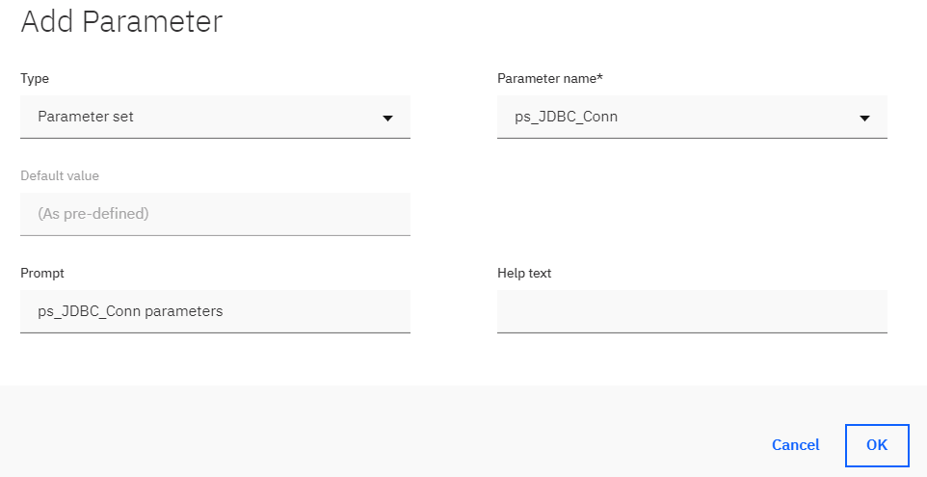
- Click on OK on the Job properties window.
- Double click on JDBC connector and the stage properties window will open.
- Change the name of the stage to JDBC_BOOKS_READ.

- In the URL textbox, click on the 3 horizontal blue dots
- A small window will appear next to the textbox. Click on #ps_JDBC_Conn.p_JDBC_URL#.
- Simillarly, select #ps_JDBC_Conn.p_Username# for User name text box and #ps_JDBC_Conn.p_Password# for Password text box.
- You can check if connector is connecting to the database successfully or not by clicking on the Test link.
- In the Table name text box, enter CP4D.BOOKS. Click on OK.
- Double clcik on the link and change its name to Link_WRITE.
- Now, double click on File Connector and change the stage name to FILE_BOOKS_WRITE.
- In the File name text box, select #p_FileName# by clciking on the 3 dots. Now, enter /mnt/dedicated_vol/Engine/ before #p_FileName# such that file name becomes /mnt/dedicated_vol/Engine/#p_FileName#. Click on OK.
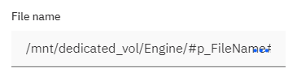
- Save the job by clicking on the save icon.
- Compile and run the job.

